REINFORCEMENT LEARNING
5. Monte Carlo Methods and Temporal-Difference Learning
5.1 Monte Carlo Prediction, Monte Carlo Estimation of Action Values, Monte Carlo Control, TD Prediction, TD control using Q-Learning
PAST QUESTIONS:
- Explain with an example scenario where Monte Carlo control might be applied. (M24)
- Describe the Q-learning algorithm for TD control. (M24)
- Explain the difference between first-visit and every-visit Monte Carlo policy evaluation methods. (M24)
- Define Temporal Difference and explain parameters of TD in detail? (M25)
- Explain the concept of Monte Carlo Prediction in reinforcement learning and describe the main steps involved in a Monte Carlo prediction algorithm. (M25)
- Write and explain off policy TD control using Q-learning? (M25)
- Explain the differences between TD learning and Monte Carlo methods. Also, describe the main components and key steps involved in TD prediction algorithms. (M25)

NOTES:

*Monte Carlo :-
Monte Carlo policy evaluation is a technique within the field of reinforcement learning that estimates the effectiveness of a policy—a strategy for making decisions in an environment. It’s a bit like learning the rules of a game by playing it many times, rather than studying its manual. This approach doesn't require a pre-built model of the environment; instead, it learns exclusively from the outcomes of the episodes it experiences. Each episode consists of a sequence of states, actions, and rewards, much like playing rounds of a game, starting from the initial state and continuing until the game ends.
The method works by running simulations or episodes where an agent interacts with the environment until it reaches a terminal state. At the end of each episode, the algorithm looks back at the states visited and the rewards received to calculate what’s known as the "return" — the cumulative reward starting from a specific state until the end of the episode. Monte Carlo policy evaluation repeatedly simulates episodes, tracking the total rewards that follow each state and then calculating the average. These averages give an estimate of the state value under the policy being followed.
By aggregating the results over many episodes, the method converges to the true value of each state when following the policy. These values are useful because they help us understand which states are more valuable and thus guide the agent toward better decision-making in the future. Over time, as the agent learns the value of different states, it can refine its policy, favouring actions that lead to higher rewards.
Monte Carlo policy evaluation is like a trial-and-error learning method where you understand the value of actions by repeatedly trying them and observing the outcomes.
The Monte Carlo (MC) method is a model-free reinforcement learning technique used to estimate the value of states or state-action pairs based on complete episodes of experience. It learns directly from actual returns without requiring knowledge of the environment's transition probabilities.
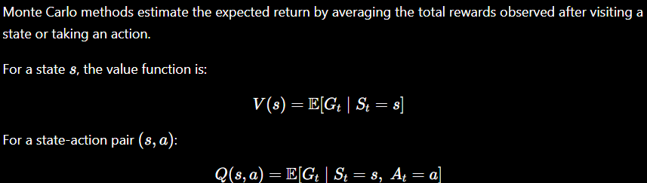
Key idea –
Instead of updating estimates after every step, Monte Carlo waits until the episode terminates and then uses the total return to update value estimates.
Thus:
- Works only for episodic tasks.
- Uses actual sampled returns.
- Does not bootstrap.

*Monte Carlo Prediction :-
Monte Carlo Prediction is a technique used to estimate the value function (the expected return) of a specific policy by averaging the actual returns observed over many complete episodes. Unlike other methods, it does not require a model of the environment's dynamics, making it a "model-free" approach that learns purely from experience.
Core Concepts
- Episodic Tasks: MC prediction is designed for tasks that have a definite end (a terminal state).
- Return (G_t): The total cumulative reward an agent receives from a specific time step t until the end of the episode.
- Value Estimation: The value of a state V(s) is estimated by taking the average of all returns observed after visiting that state across many trials
Types of MC Prediction
The method differs based on how it handles multiple visits to the same state within a single episode:
- First-Visit MC: Only the return following the first time a state is visited in an episode is averaged.
- Every-Visit MC: Every time a state is visited in an episode, the subsequent return is included in the average.
Monte Carlo Prediction Algorithm
- Initialize $V(s)$arbitrarily for all states.
- Generate an episode following policy $π$.
- For each state visited in the episode:
  - Compute return $G_{t}$.
  - Store the return.
  - Update $V(s)$as the average of all stored returns.
- Repeat for many episodes.

* Monte Carlo Control :-
Monte Carlo Control is a model-free reinforcement learning method used to find the optimal policy by estimating the action-value function $Q(s,a)$from complete episodes and improving the policy based on these estimates.
While Monte Carlo Prediction evaluates a given policy, Monte Carlo Control both evaluates and improves the policy until an optimal policy is obtained.
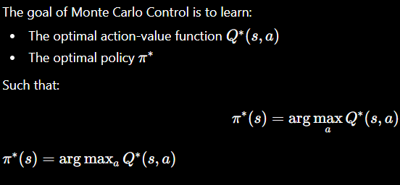
Monte Carlo Control Algorithm –
- Initialize $Q(s,a)$arbitrarily.
- Initialize a policy (often random).
- Generate an episode using the current policy.
- For each visited state-action pair:
  - Compute return $G_{t}$.
  - Update $Q(s,a)$as the average of returns.
- Improve policy:
$$π(s)=arg⁡\underset{a}{max⁡}Q(s,a)$$
- Repeat until the policy stabilizes.
Monte Carlo Control is a reinforcement learning method that estimates action values from complete episodes and improves the policy based on those estimates. By alternating between evaluation and policy improvement, it converges to the optimal policy and forms a foundational technique in model-free reinforcement learning.

*Temporal Difference :-
Temporal Difference (TD) Learning is a model-free reinforcement learning method used by algorithms like Q-learning to iteratively learn state value functions (V(s)) or state-action value functions (Q(s,a)). Unlike Monte Carlo methods that require full episodes, TD Learning updates value estimates after each time step using the Bellman equation and Temporal Difference error.
Temporal Difference (TD) Learning is a model-free reinforcement learning method used to estimate the value of states by updating predictions based on other learned predictions. It combines the strengths of Monte Carlo methods and Dynamic Programming.
- Like Monte Carlo methods, TD learns directly from experience without requiring a model of the environment.
- Like Dynamic Programming, TD updates estimates using existing value estimates before the episode ends.
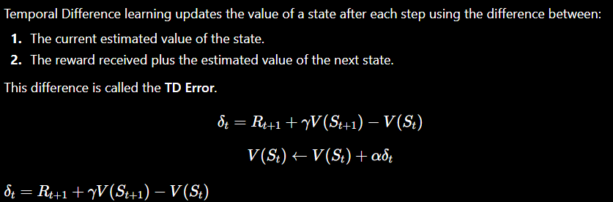
Key parameters –
- Alpha − This indicates the learning rate which varies between 0 to 1. It determines how much our estimates should be adjusted based on the error.
- Gamma − This implies the discount rate which varies between 0 to 1. A large discount rate signifies that future rewards are valued to a greater extent.
- epsilon − This means examining new possibilities with a likelihood of epsilon and remaining at the existing maximum with a likelihood of 1-epsilon. A greater epsilon indicates that more explorations take place during training.
TD(0) Algorithm Steps –
- Initialize $V(s)$arbitrarily.
- Observe current state $S_{t}$.
- Take action and receive reward $R_{t+1}$.
- Observe next state $S_{t+1}$.
- Compute TD error.
- Update $V(S_{t})$.
- Repeat until terminal state.

* TD control using Q-Learning :-
Q-Learning is a popular model-free reinforcement learning algorithm that helps an agent learn how to make the best decisions by interacting with its environment. Instead of needing a model of the environment the agent learns purely from experience by trying different actions and seeing their results.
Q-learning is a model-free, off-policy reinforcement learning algorithm used to find the optimal action-selection policy for a given Markov Decision Process (MDP).
It enables an agent to learn the best action to take in each state by interacting with the environment and maximizing cumulative rewards.
Q-learning learns the optimal action-value function, called Q-function:
$$Q(s,a)$$
Where:
- s → Current state
- a → Action taken
- Q(s,a) → Expected reward for taking action a in state s
The goal of Q-learning is to learn the optimal Q-value function:
$$Q^{*}(s,a)$$Temporal Difference (TD) learning is a method that updates values using the difference between predicted and actual reward.
TD learning updates values step-by-step rather than waiting for the final outcome.

TD Control refers to methods that use Temporal Difference learning to estimate action values and improve the policy simultaneously.
The agent:
- Takes actions in the environment.
- Receives rewards.
- Updates $Q(s,a)$using TD learning.
- Gradually learns the optimal policy.
This TD error measures how different the current estimate is from the targe TD Control using Q-Learning is a powerful reinforcement learning method that updates action values using Temporal Difference learning and the Bellman optimality principle. By repeatedly interacting with the environment and updating Q-values, the agent learns the optimal policy that maximizes long-term rewards.

